The NOMATEN Center of Excellence (CoE NOMATEN, NCBJ, Poland) runs a bi-monthly cycle of scientific seminars and conferences. Access to the conference program
The CEA (France), as a partner (with VTT, Finland) of the NOMATEN CoE, accompanies this action in the framework of the WP6 Capacity Building Programme associated with the European project of the same name (NOMATEN, EU H2020 Teaming Phase 2). Both aspects of research (Materials Science and Radiopharmaceutical Science) are addressed during these conferences.
Find below the abstracts of the invited speakers of the Joliot Institute in Radiopharmaceutical Sciences
Bertrand Kuhnast (SHFJ / BioMaps), April 19th, 2022  bertrand.kuhnast@cea.fr  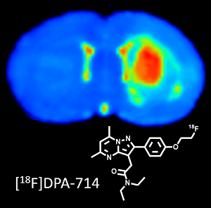  © B.Kuhnast/CEA | The Service Hospitalier Frédéric Joliot (Orsay, France) is a translational and multimodal molecular imaging facility. It gathers on the same site two cyclotrons for the daily production of positron emitters, R&D and GMP hot labs for the manufacturing of radiotracers and radiopharmaceuticals, an experimental and preclinical imaging platform comprising PET, PET/CT, SPECT/CT scanners and ultrasound devices and finally PET/CT, PET/MRI and MRI clinical scanners. Beside the clinical nuclear medicine practice, intensive research programs are dedicated to the translational development of new radiopharmaceuticals and the support and “derisking” in drug development. During this seminar, after a rapid technical overview of our facility, I will illustrate these translational developments with two selected examples: i) [¹⁸F]DPA-714, a radiopharmaceutical to image neuroinflammation: from the identification of the chemical scaffold to the clinical trials; step by step development of a radiopharmaceutical. ii) Isotopic radiolabelling of dolutegravir, an antiretroviral drug, with fluorine-18 to decipher treatment limitations: hope and pitfall in the development of a complex radiosynthesis scheme and first images.
Éric Doris (DMTS / SCBM), May 10th, 2022  eric.doris@cea.fr  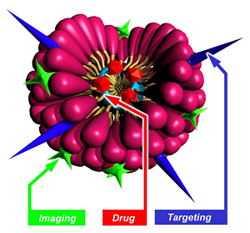  © E.Doris/E.Gravel/CEA | Medicine has been a field where nanotechnologies have shown great promise for diagnosis and drug delivery applications. The challenge of nanomedicine consists in carrying active molecules through the different biological barriers and reaching specific targets in an efficient and non-toxic way. With the advent of nanotechnologies, different carrier systems are now available. However, the development of small biocompatible carriers with high loading capacity, extended circulation time, and favorable biodistribution has several unanswered issues. This talk will give an overview of our findings regarding polymerized micelles obtained from original diacetylene-containing amphiphiles. Their chemical synthesis, assembly and characterization will be presented as well as some biomedical applications such as tumor imaging and drug delivery. Micelles were also valorized by our group for synthetic applications such as the promotion of the Huisgen 1,3-dipolar cycloaddition (“click” reaction) between alkynes derivatives and azido compounds in water. Some examples illustrating the potential of the micelles in the catalysis of the “click” reaction will be presented.
Marie-Pierre Heck (DMTS / SCBM), December 6th, 2022  marie-pierre.heck@cea.fr  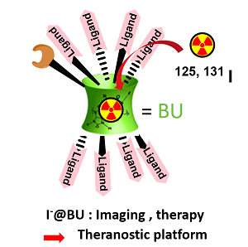  © MP.Heck/CEA | Anions and cations are ubiquitous in nature and play very important roles in many areas, such as biological research, clinical diagnosis, industries and environmental process. There recognition and monitoring are of primordial importance in biological mechanisms, medicine and environment. The design of anion receptors is particularly challenging due to their larger size than isoelectronic cation, their strong hydration, their variety of geometries, and their sensitivity to pH. Despite numerous progress have been achieved, selective anion recognition is a challenge, especially in water and biological media due to the intrinsic characteristics of anions. Our research group has designed powerful receptors of anions based on bambusuril skeleton and evaluated their affinity towards halides. These neutral cavitands with a jigger-like conformation are prepared from cheap reagents using an easy and fast synthetic procedure. We have shown that such molecules exhibit highly specific recognition for iodides in organic and aqueous media making them the most efficient complexing agents currently known for which applications as sensors and imaging agents can be envisaged. Moreover, we have shown that bambusurils can be used as multivalent plateforms to link glycosidases inhibitors derived from 1-deoxynojirimycin (DNJ). These neoglycobambusurils caging-anions have inhibitory constants in the nanomolar range.

